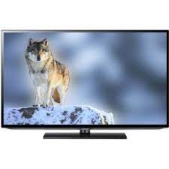

Samsung EH5000

* SRS Theater Sound HD
* Square Stand Type
* Auto Power Off Available
* Screen Size 42 Inch
* **Rs.51,999**